# Department of Computing

# database systems

# Course Instructor: Dr. shams qazi

# Lab 06

## **CS220: DB Systems**

## **Name: Mahum Samar**

# **CMS ID : 290647**

## Find the names of faculty members that has taught classes only in room R128.

SELECT fname, f.fid, c.room

FROM uni.faculty f

JOIN uni.class c using (fid)

GROUP BY fname

HAVING c.room = 'R128'

AND COUNT(c.room) = 1;

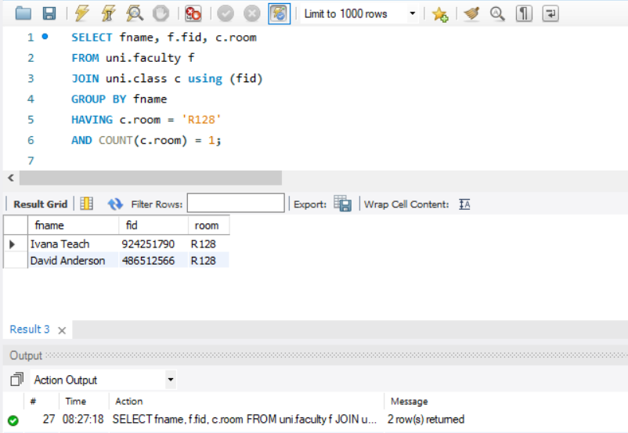

## Find the names of classes taught by ‘Richard Jackson’ and their times when a class meet there.

SELECT fname, c.cname, c.meets_at

FROM uni.class c

JOIN uni.faculty f using (fid)

WHERE fname = 'Richard Jackson';

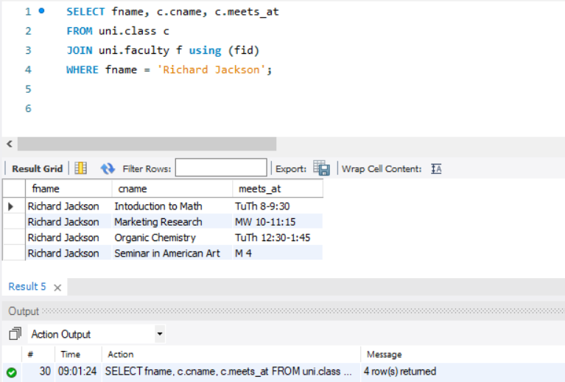

## Find the names of classes taught by ‘John Williams’ in dept # 68.

SELECT fname, c.cname, deptid

FROM uni.class c

JOIN uni.faculty f using (fid)

WHERE fname = 'John Williams'

AND deptid = 68;

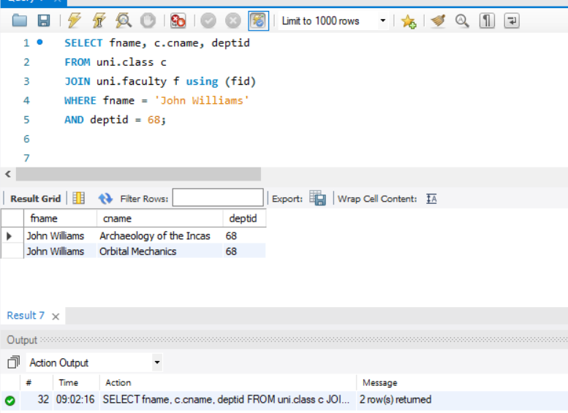

## For each class taught by ‘John Williams’, retrieve the name and age for students.

SELECT sname, age, fname, cname

FROM uni.student s

JOIN uni.enrollment e using (snum)

JOIN uni.class c using (cname)

JOIN uni.faculty f using (fid)

WHERE fname = 'John Williams';

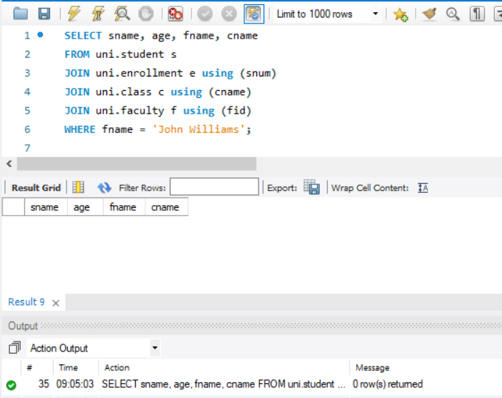

## Find the names of faculty that teach ‘Database Systems’ class in descending deptid-wise.

SELECT fname, fid, cname, deptid

FROM uni.faculty f

JOIN uni.class c using (fid)

WHERE cname = 'Database Systems'

ORDER BY deptid desc;

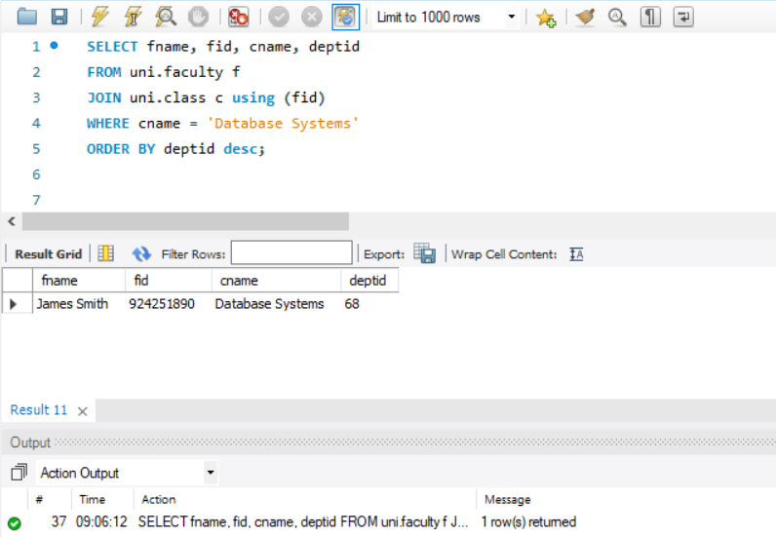

## Find distinct student ages in ‘Database Systems’ class in descending order.

SELECT DISTINCT age, cname

FROM uni.student s

JOIN uni.enrollment e using (snum)

WHERE cname = 'Database Systems'

ORDER BY age desc;

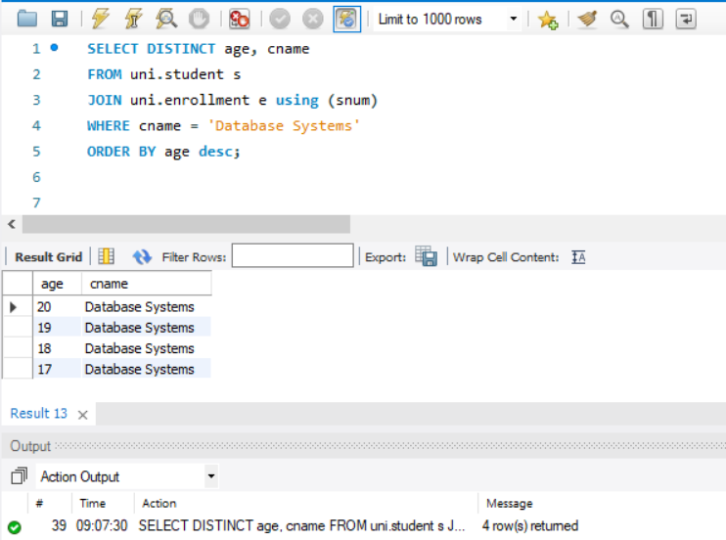

## List the name of ‘Christopher Garcia’s teachers.

SELECT sname, fname, cname

FROM uni.student s

JOIN uni.enrollment e using (snum)

JOIN uni.class c using (cname)

JOIN uni.faculty f using (fid)

WHERE sname = 'Christopher Garcia';

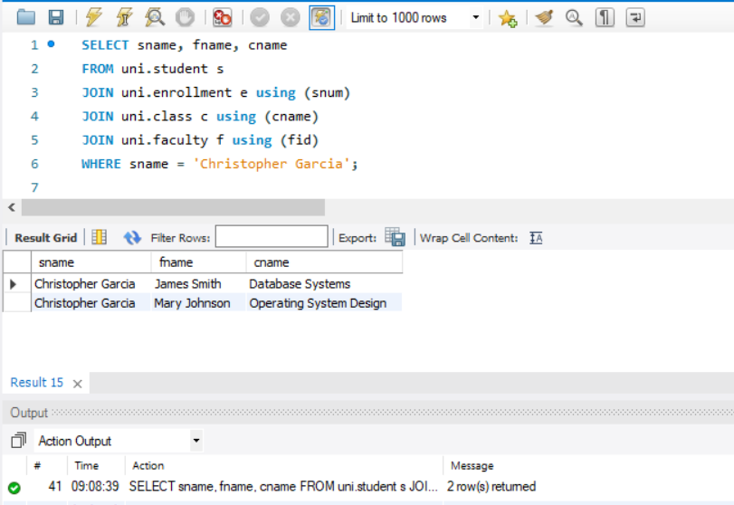

## Find the name and age of student in ‘Database Systems’ class.

SELECT sname, age, cname

FROM uni.student s

JOIN uni.enrollment e using (snum)

WHERE cname = 'Database Systems';

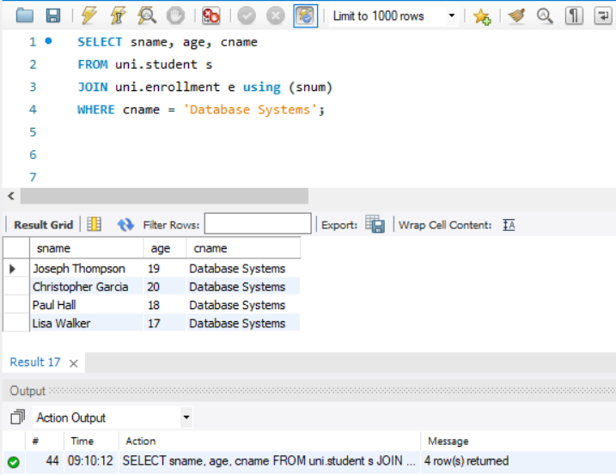

## Find the class names, strength of faculty members for each class.

SELECT cname, COUNT(f.fid) AS strength

FROM uni.class c

JOIN uni.faculty f using (fid)

GROUP BY cname;

